ASSIGHNMENT 2

MUHAMMAD AHMAD RAZA

467253

#include<iostream>

#include<cmath>

using namespace std;

//PROJECT 1

int main(){

double g; //defining variables and

cout<<"ENTER YOUR MARKS="<<endl; //and taking input from user

cin>>g;

if(g>90||g==90&&g<100||g==100) //applying if condition on marks that

{ //mark=90-100 grade=A

cout<<"A";

}

else if(g>75||g==75&&g<90) //mark=75-90 grade=B

{

cout<<"B";

}

else if(g>60||g==60&&g<75) //mark=60-75 grade=C

{

cout<<"C";

}

else if(g>45||g==45&&g<60) //mark=45-60 grade=D

{

cout<<"D";

}

else

{

cout<<"F"; //mark<45 grade=F

}

}

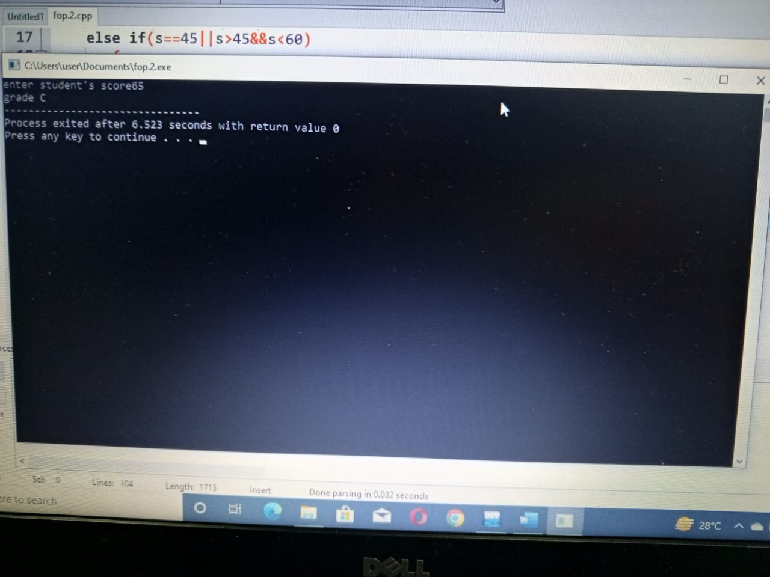

//PROJECT 2

int main(){

int integer; //defining variables and

cout<<"ENTER THE INTEGER"<<endl; //and taking input from user

cin>>integer;

if((integer/2)||(integer/5)==1) //applying if condition on integers that

{ //if it is divisible by 2 and 5

cout<<"IT IS DIVISIBLE ";

}

else

{

cout<<"NOT DIVISIBLE"; // if not divisible then print it is not divisible

}

}

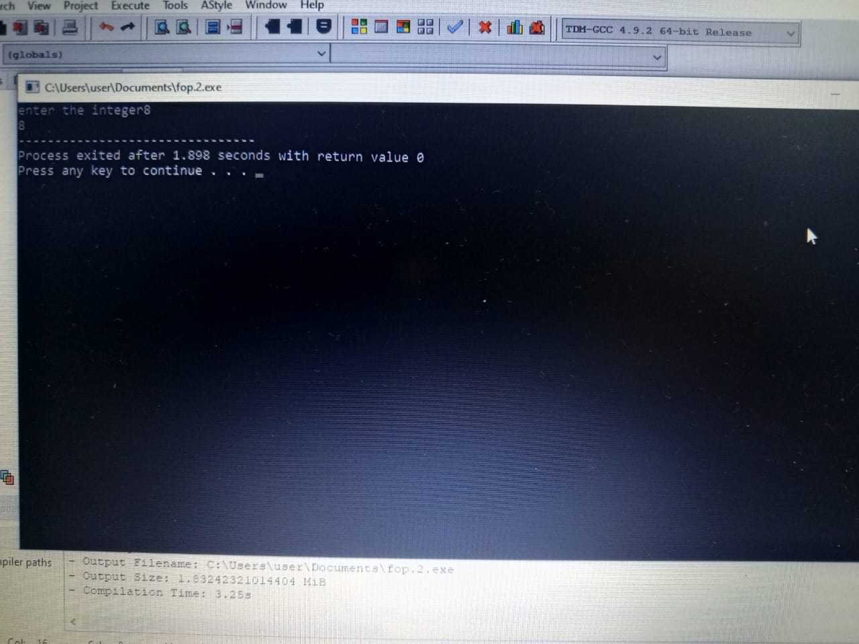

//PROJECT 3

int main(){

int y; //defining variables and

cout<<"YEAR="<<endl; //and taking input from user

cin>>y;

if(y%4==0&&y%100!=0||y%400==0) //applying if condition on integers that

{ //if it is divisible by 4 and not divisible by 100, it is leap year

cout<<"IT IS A LEAP YEAR"; //or if its disible by 400

}

else

{

cout<<"NOT A LEAP YEAR";

}

}

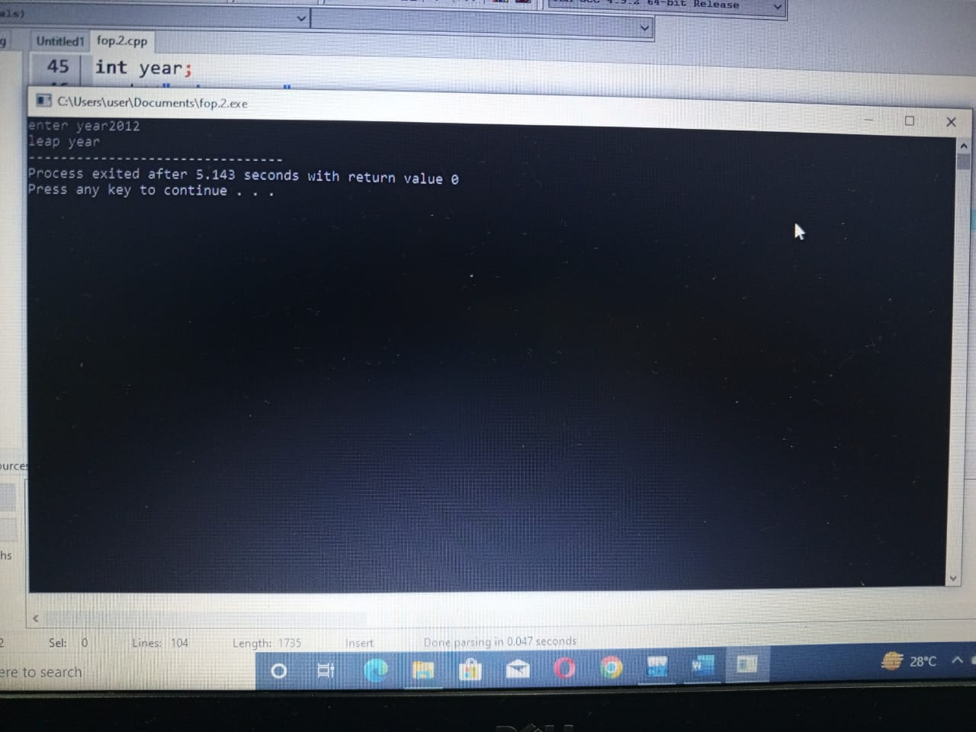

//PROJECT 4

int main(){

float GPA,a; //defining variables and

cout<<" ENTER YOUR GPA AND ATTEDENCE"<<endl; //and taking input from user

cin>>GPA>>a;

if(GPA>3.5||GPA==3.5&&a>80||a==80) //applying if condition on integers that

{ // valid for scholarship if GPA is equal or greater than

cout<<"ELIGIBLE FOR SCHOLARSHIP"; //3.5 and attendence must atleast 80%

}

else

{

cout<<"NOT ELIGIBLE FOR SCHOLARSHIP"; //else not valid for scholarship

}

}

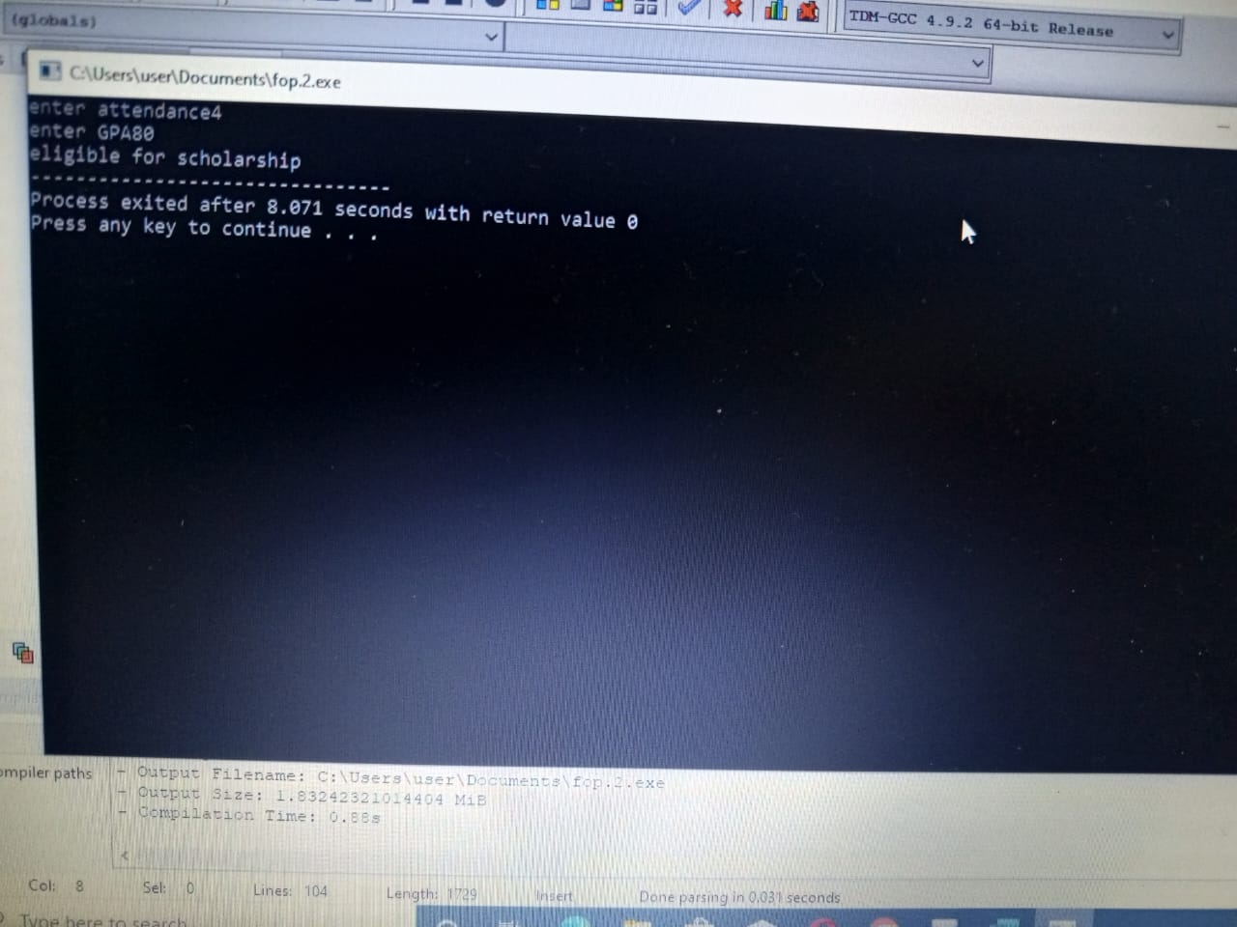

//PROJECT 5

int main(){

char A; //defining variables and

cout<<"ALPHABET="<<endl; //and taking input from user

cin>>A;

if(A=='a'||A=='e'||A=='i'||A=='o'||A=='u') //applying if condition on integers that if alphabets

{ //are vowel print vowel if not print consonents.

cout<<"IT IS VOWEL";

}

else

{

cout<<"ITS CONSONENT";

}

}

